AIPP LAB TEST -1 SOLUTIONS
Name: NAMILLA SIRI
Roll. No: 2503B05137
Branch: M.TECH (CSE)

Python Programming Lab Task Sets

Set 2
- Q1. Write a Python function `is_prime(n)` to check if a number is prime. Use an AI coding tool to generate and justify a set of test cases before implementation. Pass all generated test cases.
(Each question carries 5 marks)
Prompt: Generate a Python function is_prime(n) and create AI-justified test cases before implementing the function. Ensure the code passes all test cases and allows user input.
Code:
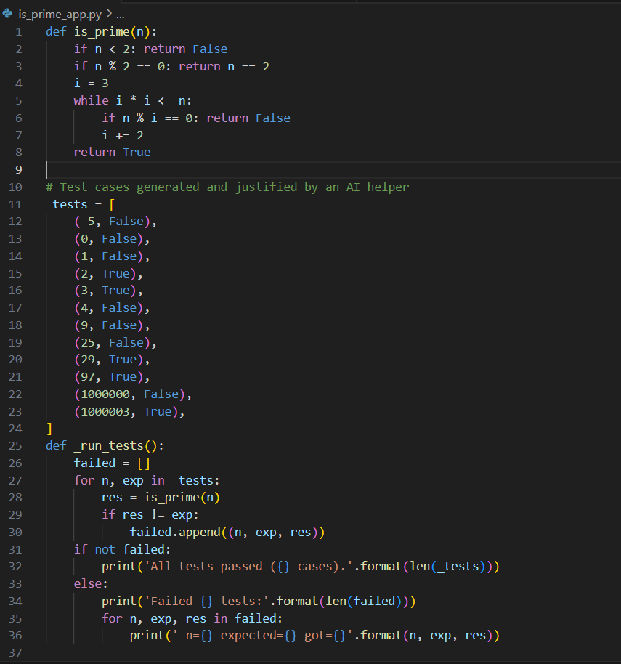
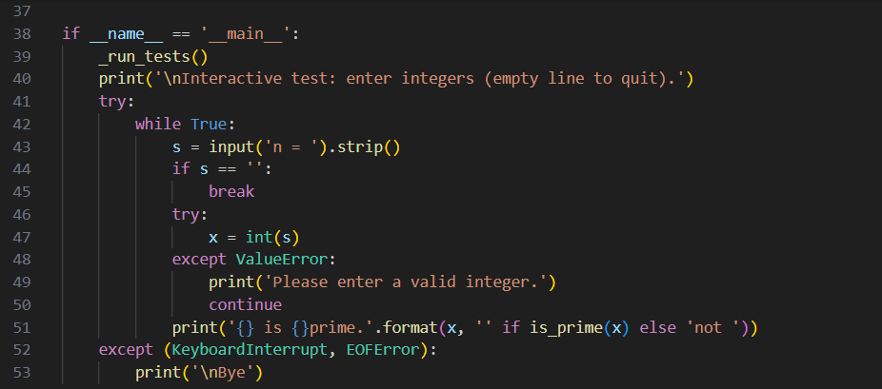
Code Explanation:
- The is_prime function checks whether a number is prime by handling small cases and then testing divisibility up to its square root.
- It first rejects numbers less than 2 and even numbers except 2.
- Then it checks only odd divisors (3, 5, 7, …) to see if any divide the number.
- A list of test cases is used to automatically verify that the function works correctly.
- If run directly, the program also lets the user type numbers and tells whether each one is prime.

Output:
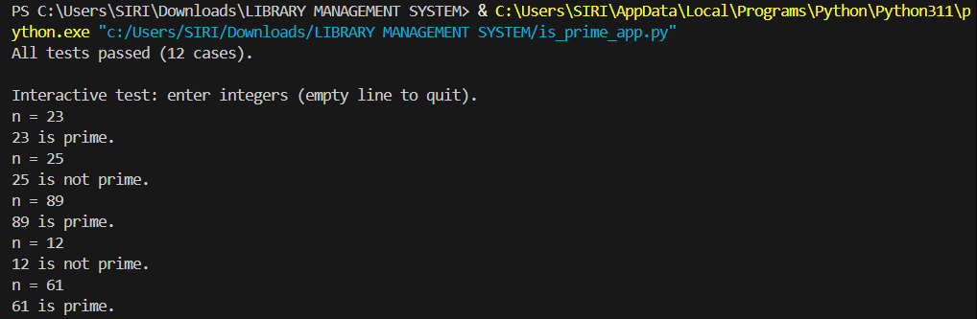

- Q2. Develop a Python class `Rectangle` with methods for area and perimeter. Use an AI assistant for auto-generating docstrings and inline comments. Compare them with your manual documentation.
(Each question carries 5 marks)
Prompt: Write a Python class Rectangle with area and perimeter methods, and use an AI assistant to auto-generate docstrings and comments; also compare them with manual documentation, and allow user to give input to check the code.
Code:
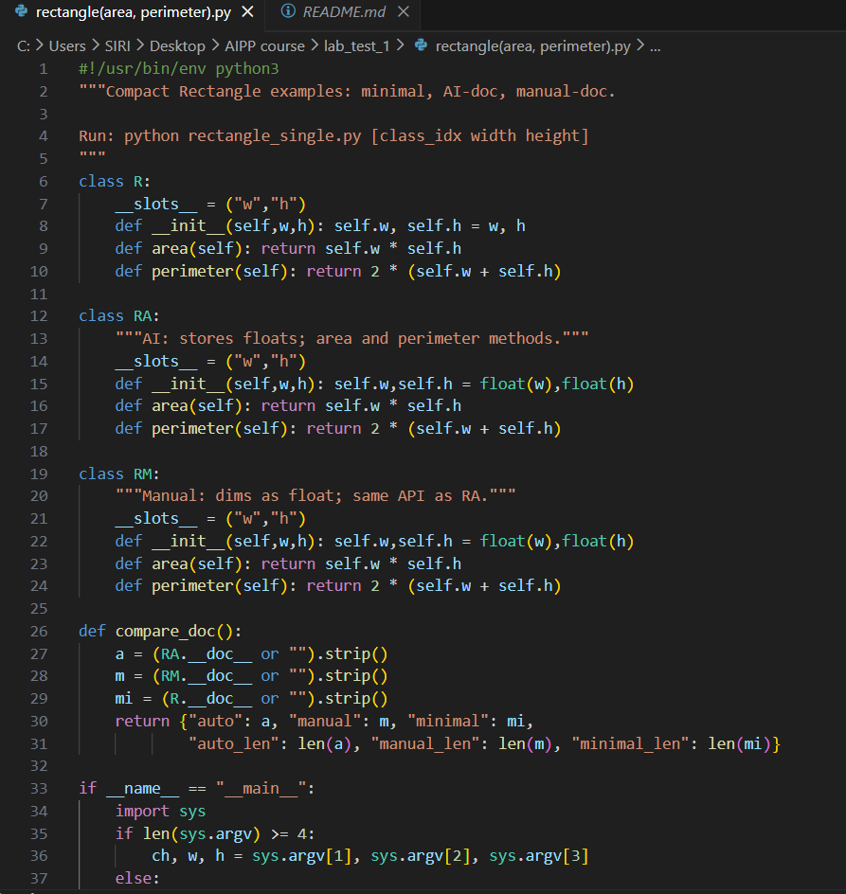
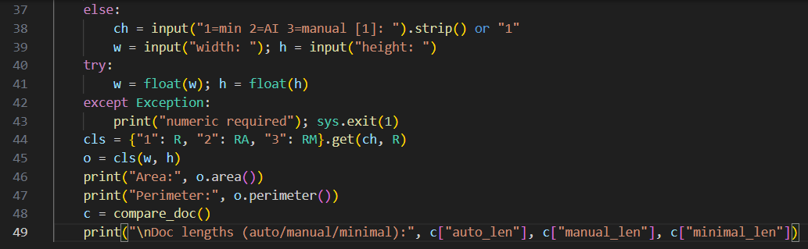
Code Explanation:
- The program defines three rectangle classes (R, RA, RM), each storing width and height and providing area() and perimeter() methods.
- R stores values as given, while RA and RM convert them to floats and include different docstrings.
- The compare_doc() function returns the docstrings and their lengths for comparison.
- In the main block, the program reads class choice, width, and height from command-line arguments or user input.
- It creates the chosen rectangle object, prints its area and perimeter, and finally prints docstring length information for the three classes.
Comparison:
1. AI-generated docstrings (class RA)
- Very short and generic.
- Gives only a basic idea: “stores floats; area and perimeter methods.”
- Missing deeper explanation, examples, or details about usage.
- Useful, but not very descriptive.
2. Manual docstrings (class RM)
- Slightly clearer and written with intention.
- Mentions that dimensions are floats and matches the class design.
- Still simple, but more meaningful because a human chooses wording.
- More likely to reflect the actual purpose of the class.
3. Minimal/no documentation (class R)
- Has no docstring at all.
- The class works, but someone reading the code must figure everything out manually.
- Good for compact code, but bad for understanding.
4. Overall comparison
- AI-generated docs are fast but sometimes vague.
- Manual docs take more effort but can explain more clearly.
- Completely undocumented code is shortest but hardest to understand.

Output:
